**Fungal Assisted Algal Lipid Extraction: An Economically Feasible Energy Solution**

Kaitlyn Loop

HSA The Economics of Oil and Energy

28 April 2016

**I. Introduction**

When I was in ninth grade, I read an article in Scientific American about how algae is going to fuel the world one day.[1] The article discussed how algae is too expensive to be competitive with oil, but could be in the future if we found ways to cut the cost. Algae biofuel production is a five-step process that involves strain identification, growing, harvesting, lipid extracting, and refining. I wanted to help come up with a solution, so I ordered some algae online and began growing it in my bedroom. Over the next couple of years, I teamed up with my sister and we researched different steps of the five-step process from our bedrooms and high school laboratory. This year, my sister, McKenna Loop, studied the lipid extraction step and designed a new method for extracting lipids from algae, fungal assisted lipid extraction, that cuts the cost by 74%.[2] In this paper I will argue that the innovative fungal lipid extraction method makes algae an economically feasible and competitive source of biofuel compared to corn and soy. Additionally, I will present ways in which using algae as a source of energy can help combat issues of food shortage, pollution, land shortage, and water consumption when compared with corn and soy.

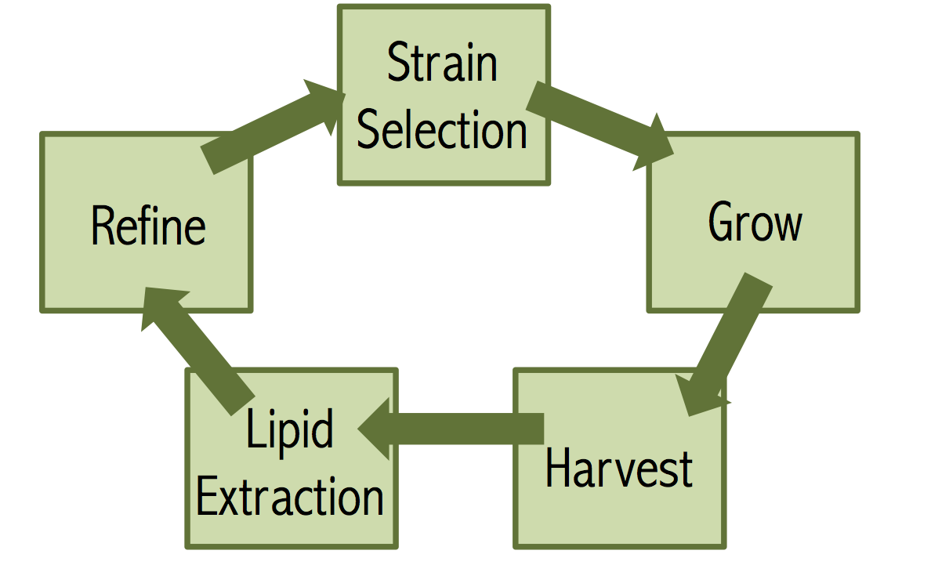**II. Five Step Process**

*Figure 1:* Diagram produced by Kaitlyn Loop that outlines the five-step process of algae biofuel production. Image created by Kaitlyn Loop.

Figure 1 shows the five-step process in which algae biofuels are made. I will now discuss the five steps in detail. The first step is strain selection. There are over 60,000 strains of algae that have been discovered. Algae is divided into macroalgae and microalgae. Macroalgae is like seaweed and kelp. Microalgae is what is used for biofuel production. Within microalgae there are blue-green algaes, green algaes, red algaes, and brown algaes. Green, red, and brown algaes reproduce through photosysthesis where as blue-green algaes grow heterotrophically. Growing heterotrophically means they can grow in the dark using sugars as nutrients. Green algae is what is used for biofuel production mainly because they grow through photosynthesis and are known to have high lipid content.[3]

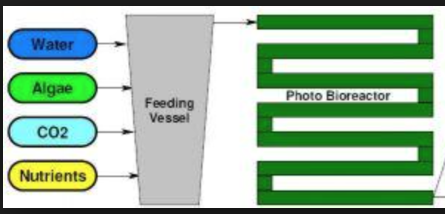 The second step is growth. There are currently two methods of growing green algae strins. The first is in a photobioreactor. Photobioreactors, shown in figure 2, are closed, controlled systems. The algae and nutrients are pumped into the tubes of the photobioreactor. The photobioreactor uses sensors to control the temperature and nutrient supply. The second method for growth is the open raceway pond. Open raceway ponds are very shallow and use paddles to keep the algae circulating. The drawback of open ponds is contamination.

*Figure 2:* Diagram of the photobioreactor growth system. Image from www.oilgae.com.

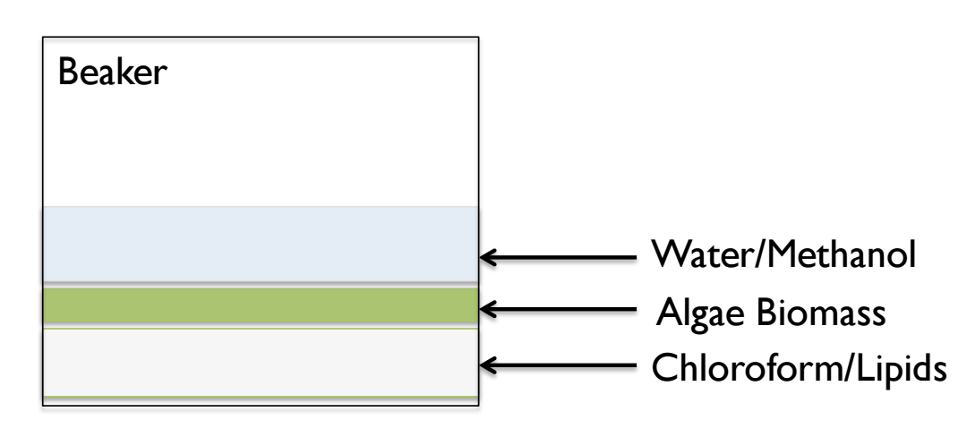 The third step is harvesting which involves removing the algae from the medium it is growing in. The most common harvesting method is centrifugation, but not the cheapest.[4] This method uses centripetal force to concentrate the algal mass. The fourth step is lipid extraction, which extracts the lipids form the algae. The current baseline method for lipid extraction is called Bligh and Dyer.[5] The Bligh and Dyer method uses a hydrophobic solvent, chloroform, to pull the lipids out of the cell. After the extraction, the algae, water, chloroform, and lipids form separate layers, which can be seen in figure 4. The chloroform and lipids are then centrifuged out and the chloroform is evaporated leaving just the lipids behind. Lastly, the lipids are then refined in the fifth-step of production.

*Figure 3:* Diagram of the baseline lipid extraction method – Bligh and Dyer. Image produced by McKenna Loop.

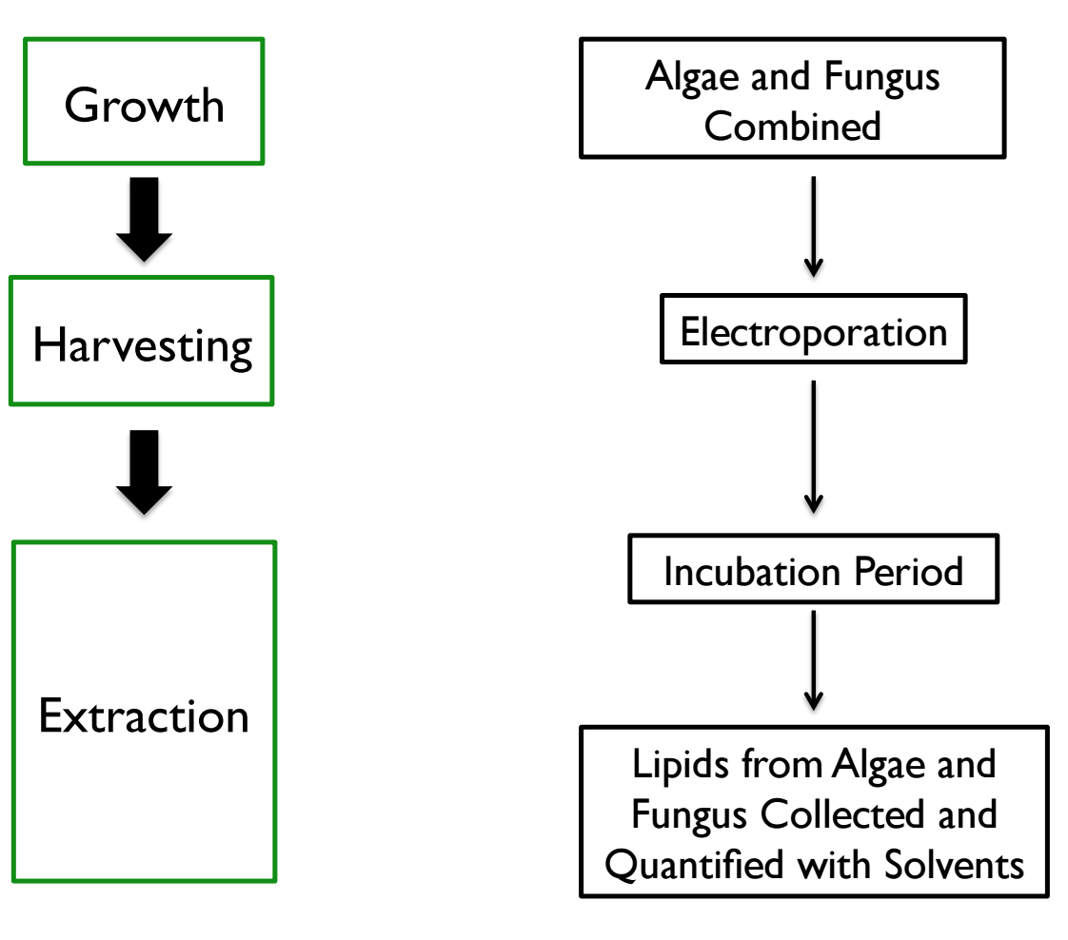**III. New Method of Production**

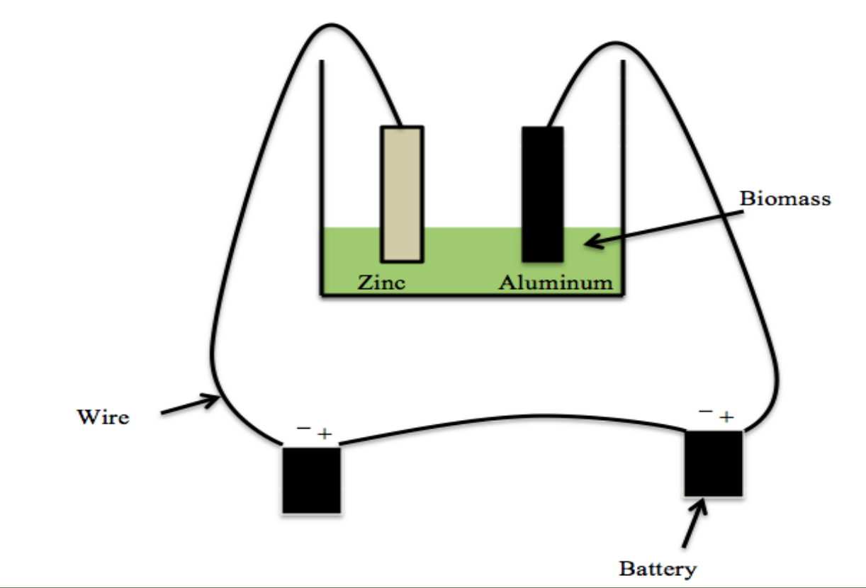 The new method of algae biofuel production, designed by McKenna Loop, is called fungal assisted algae lipid extraction. Figure 4 shows a picture of how the process will work. I will discuss the process now. During the growth stage, Chlorella Vulgaris, a green algae strain, and Aspergillus Niger, a fungus, symbiotically grow in wastewater. When algae and fungus grow together, they create a new life form called a lichen.

*Figure 4:* Diagram of the new fungal assisted algal lipid extraction method. Diagram produced by McKenna Loop.

After growth, a novel harvesting method designed by McKenna and me, called electroporation will be used.[6] Figure 5 is a diagram representing the electroporation method. Electroporation uses an anode, cathode, and battery. An aluminum plate and zinc plate are placed in the algae-fungus mixture. Current is then run through the system making the algae flocculate (clump together). The choice of aluminum and zinc plates makes it so the algae cells do not die. However, their cell wall is weakened, which makes the lipid extraction easier. Additionally, the fungal cell wall is broken and the enzymes from the fungus are released into the mixture. The electroporation can be run in batch cycles by running current through and then scooping the flocculated cells off the top. Then the cycle is repeated for multiple cycles until almost 100% of the algae cells are recovered.

*Figure 5:* Diagram depicting the electroporation harvesting method. Image produced by Kaitlyn Loop.

Lastly, the innovative fungal assisted lipid extraction method is used. The enzymes, cellulase and trypsin, are extracted from the fungus during electroporation and break down the algae cell wall. This makes the solvent extraction much easier and cheaper. An economic analysis will be done in section V. The fungus is used to provide enzymes to break down the cell wall. Then the Bligh and dyer method is used to extract the lipids and separate out the leftover algae mass, lipids, and fungal enzymes into layers.

**IV. Added Benefits of Algae Biofuels**

1. **Land Solution**

The problem with other sources of biofuel such as corn and soy is that they require too much land to produce small amounts of fuel. Let’s look at one acre of land and see how much energy we can get out of it based on the source of biofuel. If we grow corn on one acre of land, we will get 420 gallons (citation) of oil per year. On average, each person per year consumes 924 gallons of oil (citation). One acre of corn only produces 45% of what the average person needs per year. If we look at soy, we see that one acre of soy only produces 70 gallons of oil per year. This is worse than corn and is only 8% of total oil demand for one person per year. Lastly, one acre of algae produces 5,000 gallons of oil per year.[7] This is enough oil for roughly 5 people per year and is 1190% efficient than corn. This also means that if we converted all of our energy usage to algae, we would be able to produce enough fuel just by covering the entire state of Arizona in algae. Where as if we used corn or soy, we would need more than three times the size of the United States. Why can algae produce so much more oil per year than corn and soy? Algae has a higher energy content. Even though algae, soy, and corn all have about 20% lipids, the energy in algae’s lipids is about 2000% greater.

1. **Food Shortage**

Another problem with using corn and soy as biofuels is that they compete with the food industry. In fact, the top ten sources of biofuel in the United States today compete with the food industry. Having enough food for all of the people living in the world is a big problem many organizations are trying to find a solution to. For example, the Food and Agriculture Organization of the United Nations says that world food production is going to need to rise by 70% in order to meet demand.[8] Increasing food production by this amount will require millions of hectares of land. Competing for this land is the increase in production of biofuels. It is predicted that by 2030, 35 million hectares of land will be needed for biofuel production, which is mainly ethanol production from corn. If instead we were to use algae, we can carry out the calculation below.

$$1 hectare=2.5 acres$$

$$35000000 hectares*\frac{2.5 acres}{1 hectare}=87500000 acres of land$$

$$420\frac{gallons}{acre}*87500000 acres= 36,750,000,000 gallons$$

$$36,750,000,000 gallons*\frac{1 acre}{5000 gallons }=7350000 acres$$

$$7350000 acres*\frac{1 hectare}{2.5 acres}≈3 million hectares$$

I will explain the calculation now. First, we can convert the amount of hectares to acres. Next, we can figure out how many gallons of oil 87500000 acres of land can produce if we assume it is all corn. We will also assume that on average corn can produce about 420 gallons of oil per acre. Then we will see how many acres of land it will take to make that same number of gallons of oil but instead with algae. We will use the fact that algae can produce about 5,000 gallons of oil per acre of land. Converting acres back to hectares, using algae instead only takes about 3 million hectares of land. This means than we will free up 32 million hectares of land for food production, which will help the world get closer to raising food production by 70%.

1. **Pollution**

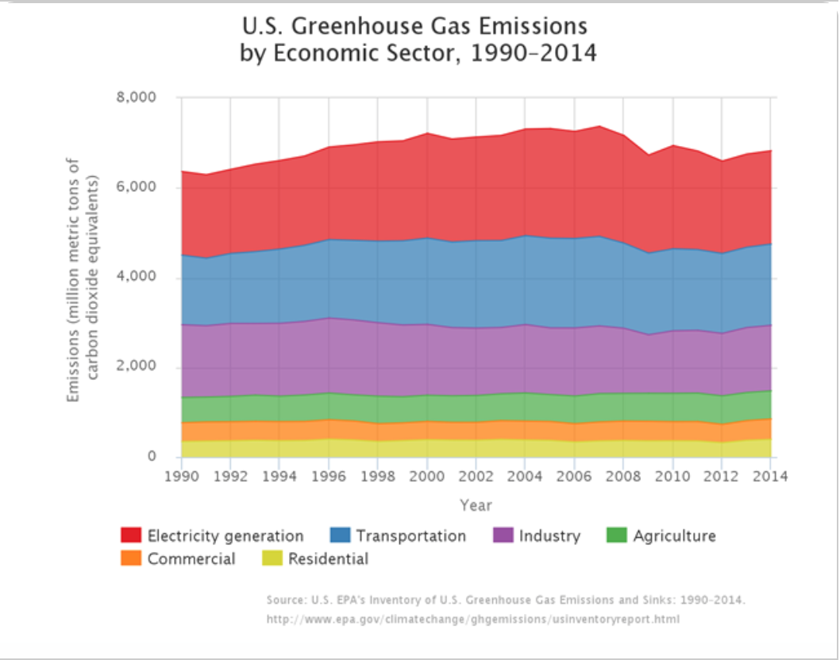A problem with the current sources of fuel used by the United States and across the world is their high greenhouse gas emissions. Figure 7 shows the breakdown of carbon dioxide emissions by sector. From the figure we can see that electricity generation, transportation, and industry produce the greatest amount of carbon dioxide. One way we can combat this issue is by implementing algae as a biofuel. Since algae grows through photosynthesis, it needs large amounts of carbon dioxide to grow. Therefore, as it grows, it can sequester carbon dioxide and act as a carbon dioxide scrubber. Researcher Richard Sayre claims that between 1.6 and 2 grams of carbon dioxide can be captured for every gram of algal biomass produced. We can also use the fact that 14 tons of algae biomass is produced per acre per year. For every ton of algae grown, 2 tons of carbon dioxide are sequestered. If there are 14 tons of algae per acre, 28 tons of carbon dioxide is sequestered per acre.[9] This means that if we fill 7350000 acres with algae, this is the number of acres of agricultural biofuel production land that will be added by 2030, we will be able to sequester 205800000 tons carbon dioxide per year. Referring back to figure 6, we can conclude that 205 million tons of added carbon dioxide sequestration will help make an impact on the 6000 million tons of carbon dioxide emitted per year.

*Figure 6:* Diagram showing the contribution of greenhouse gases from different sectors. Image from US Department of Energy.

1. **Water Shortage**

One last problem I will discuss is the amount of water needed to produce biofuel from different biofuel sources. First let’s investigate soy. According to the US Department of Energy, to produce one gallon of soy biofuel, 6200 gallons of water is needed. Additionally, to produce 1 gallon of ethanol, 1000 gallons on water is needed.[10] That means to fill up your car with about 20 gallons of gas requires 20,000 gallons of water. That is a lot of water that is being taken away from irrigation, food production, drinking, and bathing. Algae on the other hand uses can be grown in wastewater. Additionally, as the algae, grows, it actually removes the ammonium, nitrogen, and phosphorus in the wastewater. This makes the water usable again. So to produce 1 gallon of algae biofuel, 0 gallons of clean water is needed.

**V. Cost**

Lastly, let’s see how using the new fungal lipid extraction method is going to cut the cost of algae biofuel production. The current cost of algae biofuel production from start to finish is $20 per gallon (reported by the US Department of Energy). This number includes growth in a photo bioreactor, harvesting through centrifugation, and lipid extraction using the Bligh and Dyer method. The cost per gallon of the new fungal lipid extraction method is $4.88 per gallon. Let’s do some calculations to see how we get a cost reduction of 74%.

First we will calculate the cost of the lipid extraction step because that is where the cost reduction is going to occur. The formula we will use is

$\frac{C}{M\left(\frac{0.264}{0.88}\right)}$ = Extraction cost

C is the cost of the materials for extraction. M (kg) is the mass of algal lipids extracted. 0.264 gal/L is the number of gallon in one liter. 0.88 kg/L is the density of algal lipids. The equation has to include the number of gallons per liter and density of algal lipids so the equation can calculate the cost per gallon of extraction. Now we can calculate the cost based on data acquired by McKenna Loop.

First we will calculate the cost of the Bligh and Dyer method based on McKenna Loop’s data from this method to see if it matches up with the $20 reported by the department of energy. The cost of materials includes a vortex, centrifuge, evaporator, methanol, and chloroform. The cost of the vortex, centrifuge, and evaporator only include the cost of electricity because the capital cost will disappear over time. The cost of electricity per kilowatt hour is $0.0611. Based on how long each piece of equipment is used we arrive at the total cost of electricity for these three pieces of equipment to be $0.000099. The chloroform and methanol cost based on how many milliliters are used is $0.00245. The average algal lipids extracted using the Bligh and dyer method is 4.33 grams or 9.53%. Putting these numbers into the equation we get a total cost of extraction to be $2.65.

$\frac{0.003445}{0.00433\left(\frac{0.264}{0.88}\right)}$ = Extraction cost

The cost of materials for fungal assisted lipid extraction includes the cost of electroporation, the cost of the fungus, and the Bligh and dyer method. Section II of the paper explains why we need these three costs. After removing capital costs from electroporation, we just have the cost of using the batteries which is 0.00002494 $/Kwh. The cost of the fungus is 0.002628 $/mm. The Bligh and Dyer cost is $0.00344. Summing these costs we get the total fixed cost of $0.00609. The average mass of algal lipids extracted using the fungal lipid extraction method is 9.53 grams, which is 20.83% of the total mass of the algae. To put this in perspective, on average, chlorella vulgaris has 20% lipid content. Putting these numbers into the equation we get a total extraction cost of $2.13.

$\frac{0.002628+0.00344}{0.00953\left(\frac{0.264}{0.88}\right)}$ = Extraction cost

The next equation we will use is the percent yield improvement equation. This will help us get the cost of growth and harvesting, because if we can extract more lipids per algae cell, then we will have to grow less algae, and consequently, harvest less. The equation we will use is:

$$\frac{\%L-0.095}{0.095}=percent yield improvement$$

%L represents the percent lipid mass yield out of the total mass of algae. 0.095 represents the percent lipid mass yield of the Bligh and dyer method. Any change from 9.5% of lipids extracted will change the cost of growth and harvesting. Let’s calculate the percent yield improvement for the fungal lipid extraction method. The percent lipid mass yield for the fungal lipid extraction method is 20.83%. When we plug this into the equation, the percent lipid yield improvement is 83%.

We can now use this information to calculate the total cost of growth, harvesting, and lipid extraction. The formula we can use is:

$$16.2\left(1-Y\right)+ E=total cost$$

16.2 represents the baseline cost of growth and harvesting reported by the department of energy. Y is the percent lipid improvement from equation 2 and E is the total cost of extraction from equation 1. For the fungal lipid extraction method, we plug in 0.83 for Y and $2.13 for E. We get $4.88 for the total cost. For the baseline Bligh and Dyer method we plug in 0 for Y and $2.65 for the total cost.

**VI. Conclusion**

How does this new method compare to corn and soy based biofuels? Ethanol is reported at $1.86 per gallon and soybean oil is reported as $2.70 per gallon by the US Department of Energy at the beginning of 2016. Algae biofuel production is clearly higher than these values. However, the new fungal lipid extraction method has made algae biofuels competitive with the other sources of biofuel which hasn’t been the case in the past. Nobody is ever going to pay $20 per gallon to fill up their car with gas. Externality costs such as land costs, carbon dioxide production, competition wit the food market, and competition for water are not considered here, and so the cost and feasibility of using algae versus corn and soy based biofuels clearly makes algae competitive with ethanol and soy. More research is still needed in the area of algae biofuel production, but the fungal lipid extraction method has cut the cost tremendously and gives hope for algae biofuels in the near future. The US Department of Energy put $18 million dollars into algae research in July 2015 with the goal of reducing the cost to $3 a gallon. McKenna Loop’s fungal assisted lipid extraction gets us 90% of the way there.

1. Howell, Katie. "Is Algae the Biofuel of the Future?" *Scientific American*, April 28, 2009.
2. Loop, McKenna. *Fungal Assisted Algal Lipid Extraction*. Arizona Center for Algae Technology and Innovation. February 07, 2016.
3. http://allaboutalgae.com/what-are-algae/
4. Abishek, Monford Paul. "Algae Oil: A Sustainable Renewable Fuel of Future." *Biotechnology Research International*, 2014.
5. Axelsson, Martin. "A Single-Step Method for Rapid Extraction of Total Lipids from Green Microalgae." February 24, 2014.
6. Loop, Kaitlyn, and McKenna Loop. *The Effect of Different Harvesting Methods on the Amount of Algae Recovered for Biofuel Production*. Arizona Center for Algae Technology and Innovation. March 10, 2014.
7. http://www.worldwatch.org/node/5391
8. http://www.fao.org
9. Sayre, Richard. "Microalgae: The Potential for Carbon Capture." *Oxford Journals*, 2010, 722-27.
10. http://www.energy.gov